Ellie Alexander – Bakeshop Mystery Series

Need something light to read while you’re stuck at home? Try this series of cozy mysteries. The books even include some recipes to try for yourself.
Ashland, Oregon is a quaint town right out of Shakespearean England. Juliet Capshaw returns to help with the family bakery, Torte. Business is booming with the upcoming Oregon Shakespeare Festival but when the newest board member is found murdered Juliet finds herself turning from pastry chef into a detective.
If you are a mystery lover or just a lover of pastries, you will find this series a tasty treat.

Bakeshop Mystery
1. Meet Your Baker (2014)
2. A Batter of Life and Death (2015)
3. On Thin Icing (2015)
4. Caught Bread Handed (2016)
5. Fudge and Jury (2017)
6. A Crime of Passion Fruit (2017)
7. Another One Bites the Crust (2018)
8. Till Death Do Us Tart (2018)
9. Live and Let Pie (2018)
10. A Cup of Holiday Fear (2019)
11. Nothing Bundt Trouble (2020)
12. Chilled to the Cone (2020)
Trouble Is Brewing

If you like this author, you might also like these authors:
Diane Mott Davidson
Sarah Graves
Joanne Fluke.

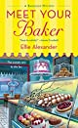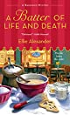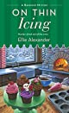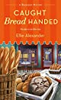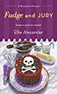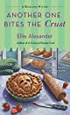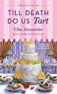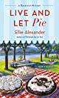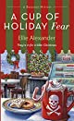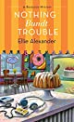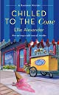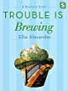

Wendelin Van Draanen – “The Running Dream”

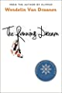
When Jessica loses her leg in a car accident, she feels like her life is over. With the help of her parents, friends, coach, and track teammates, she struggles to fulfill her dream of running again. This award-winning book shows how to overcome handicaps with courage and grace.

“Inspirational. The pace of Van Draanen’s prose matches Jessica’s at her swiftest. Readers will zoom through the book just as Jessica blazes around the track. A lively and lovely story.” —Kirkus Reviews

Other books by Wendelin Van Draanen
Sa mm
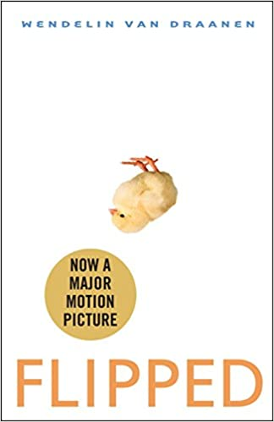 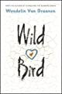 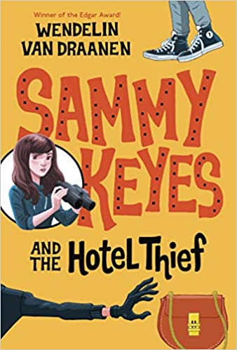

House Cleaning – nonfiction

Now that we’re all stuck at home, many of us are using some of our time to “clean up the clutter”. Here are a few books we have at Schmaling to help you clean out your closets.

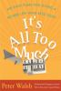

It's all too much : an easy plan for living a richer life with less stuff / Peter Walsh

640 WAL

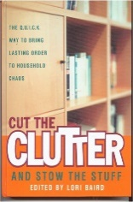
Cut the clutter and stow the stuff : the Q.U.I.C.K. way to bring lasting order to household chaos / edited by Lori Baird

648.8 CUT

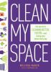

Clean my space : the secret to cleaning better, faster--and loving your home every day / Melissa Maker

648.5 MAK

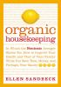

Organic housekeeping : nontoxic techniques that save your health, your time, and your money / written and illustrated by Ellen Sandbeck

648.5 SAN

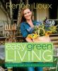
Easy green living : the ultimate guide to simple, eco-friendly choices for you and your home / Renée Loux

640.22 LOU

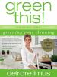

Greening your cleaning / Deirdre Imus

648.5 IMU

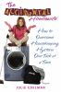
The accidental housewife : how to overcome housekeeping hysteria one task at a time / Julie Edelman

640 EDE

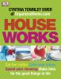
House works : cut the clutter, speed your cleaning, and calm the chaos / Cynthia Townley Ewer of OrganizedHome.com

648.8 EWE

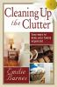
.
Cleaning up the clutter / Emilie Barnes

640 BAR

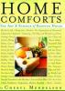
Home comforts : the art and science of keeping house / Cheryl Mendelson ; illustrations by Harry Bates

640 MEN

