Bernard Cornwell – The Last Kingdom Series Historical Fiction

Set in Great Britain in the time of Alfred the Great, this series focuses on the struggles between the Danes and the Saxons to control England. The story is seen through the eyes of Uhtred, a dispossessed English nobleman. Captured as a child and raised by the Danes, he now finds his allegiances divided. He wants to reclaim the land of his father but he also feels a strong loyalty to his new Danish family.

Last Kingdom
1. The Last Kingdom (2004)
2. The Pale Horseman (2005)
3. The Lords of the North (2006)
4. Sword Song (2007)
5. The Burning Land (2009)
6. Death of Kings (2011)
7. The Pagan Lord (2013)
8. The Empty Throne (2014)
9. Warriors of the Storm (2015)
10. The Flame Bearer (2016)
11. War of the Wolf (2018)
12. Sword of Kings (2019)
13. War Lord (2020). T
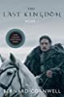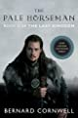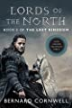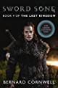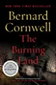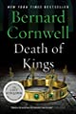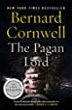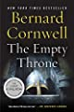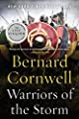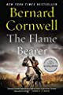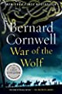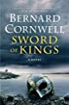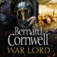
he
Last Kingdom (2004)
These books have now been made into a television series running on NetFlix.

Other books by Bernard Cornwell:
- Fools and mortals : a novel / Bernard Cornwell
- 1356 : a novel / Bernard Cornwell
- The fort : a novel of the Revolutionary War / Bernard Cornwell
- Aginecourt / Bernard Cornwell
- Waterloo : the history of four days, three armies, and three battles / Bernard Cornwell

Young Adult Fiction – Ghost stories/ murder/revenge
Free verse novel

- Nominated by teen readers for the 2020 Abraham Lincoln Award
- 2021 Rebecca Caudill Award Nominee
- Winner of the Walter Dean Myers Award
- An Edgar Award Winner for Best Young Adult Fiction

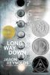
Long way down / Jason Reynolds

As Will, fifteen, sets out to avenge his brother Shawn's fatal shooting, seven ghosts who knew Shawn board the elevator and reveal truths Will needs to know.

“An intense snapshot of the chain reaction caused by pulling a trigger.” —Booklist (starred review)

Other books by this author:
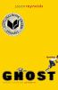

Ghost / Jason Reynolds

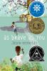

As brave as you / Jason Reynolds

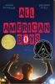
All American boys / Jason Reynolds

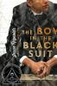
The boy in the black suit / Jason Reynolds

Keto Diet – Nonfiction – Ketogenic Diet / Cookbooks
Putting on pounds while staying at home? You might try the popular Keto Diet. Here are the books the library has to help you.

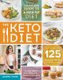
The keto diet : the complete guide to a high-fat diet -- with more than 125 delectable recipes and 5 meal plans to shed weight, heal your body, and regain confidence / Leanne Vogel 613.25 VOG

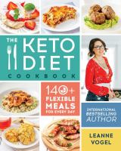
The keto diet cookbook : 140+ flexible meals for every day / Leanne Vogel

641.5638 VOG

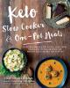
Keto slow cooker & one-pot meals : over 100 simple & delicious low-carb, paleo and primal recipes for weight loss and better health / Martina Slajerova 641.5 SLA

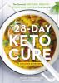
The 28-day keto cure : the essential low-carb, high-fat, weight loss plan for a healthier life / Jürgen Vormann, PhD, with Nico Stanitzok
641.5 VOR

