Week 5 Nonfiction- Job searching
Many people are now searching for a different job.
These sources may help you.

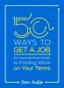
50 ways to get a job : an unconventional guide to finding work on your terms / Dev Aujla 2018

650.14 AUJ

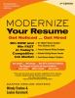
Modernize your resume : get noticed ... get hired / master resume writers Wendy Enelow & Louise Kursmark 2019

640.142 ENE

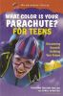
What color is your parachute? for teens : discovering yourself, defining your future / Richard Nelson Bolles and Carol Christen, with Jean M. Blomquist 2006

Y 331.702 BOL

YA author – Geoff Herbach
Geoff Herbach is the author of the award winning Stupid Fast YA series as well as Fat Boy vs the Cheerleaders.
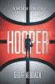

Hooper / Geoff Herbach

This book has been nominated by high school students for the 20202 Abe Lincoln Award. Hoopers is a compelling new YA novel about basketball, prejudice, privilege, and family, perfect for fans of Jordan Sonnenblick, Andrew Smith, and Matt de la Peña.

Other books by this author:
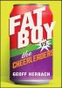

Fat Boy vs. the cheerleaders /
Geoff Herbach

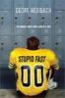
Stupid fast / Geoff Herbach

YA author – Suzanne Collins fantasy
Lovers of the Hunger Games series will love this new addition.

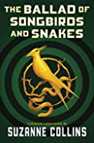 | The Ballad Of Songbirds And Snakes  It is the morning of the reaping that will kick off the tenth annual Hunger Games. In the Capitol, eighteen-year-old Coriolanus Snow is preparing for his one shot at glory as a mentor in the Games.

Other books by this author:

Hunger Games
0. The Ballad Of Songbirds And Snakes (2020)
1. The Hunger Games (2008)
2. Catching Fire (2009)
3. Mockingjay (2010)

