RA List Week 4 Thursday
Kiera Cass – Young Adult Fantasy
This hugely popular Young Adult author is a #1 New York Times bestseller.
Series
Selection
0.5. The Selection (2012)
2. The Elite (2013)
2.5. The Guard (2014)
2.6. The Favorite (2015)
3. The One (2014))
4. The Heir (2015)
5. The Crown (2016)
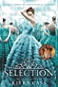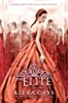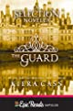
--------------------------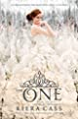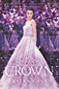

Selection Omnibus
The Selection Stories Collection (2014)
The Prince & The Guard (2014)
The Queen / The Favourite (2015)
Happily Ever After (2015
Be
trothed

- 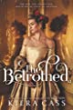11.. The Betrothed (2018) The Betrayed (2021)
021)

Kiera Cass recommends:
Kier
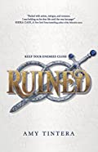
Ruined (2016)
(Ruined , book 1)
Amy Tintera
"Amy Tintera’s Ruined is so packed with action, intrigue, and romance, I was holding on for dear life until the very last page!"
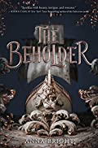
The Beholder (2019)
(Beholder , book 1)
Anna Bright
"Sparkles with beauty, intrigue, and romance. The Beholder will leave you clutching your poor heart and aching for the sequel."

Week 4 Nicola Yoon – Young Adult Romance
Kiera is a #1 New York Times Bestselling author. Her book Everything, Everything has been nominated by Illinois high school students for the 2020 Abe Lincoln award.

Novels
Everything, Everything (2015)
The Sun Is Also a Star (2016)
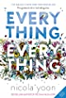

Nicola Yoon recommends
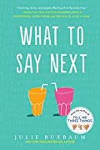
What to Say Next (2017)
Julie Buxbaum
"Charming, funny, and deeply affecting all at the same time."

Non fiction : Aging
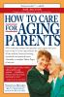
How to care for aging parents / by Virginia Morris
362.6 MOR

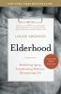
Elderhood : redefining aging, transforming medicine, reimagining life / Louise Aronson
362.6097 ARO

Fit to retire? Your guide to successful aging and a new model for retirement / William G. Nelson, MA
613.2 NEL

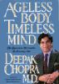
Ageless body, timeless mind : the quantum alternative to growing old / by Deepak Chopra
612.6 CHO

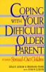
Coping with your difficult older parent : a guide for stressed-out children / Grace Lebow & Barbara Kane, with Irwin Lebow
306.874 LEB

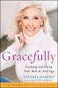
Gracefully : looking and being your best at any age / Valerie Ramsey with Heather Hummel
646.79 RAM

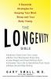
The longevity bible : 8 essential strategies for keeping your mind sharp and your body young / Gary Small with Gigi Vorgan
613.2 SMA

