YA fiction- Race relations / Police shootings
Teens from all over the state voted, and here is the winner of the 2019 Lincoln Award, the Illinois Teen Readers' Choice Award sponsored by the Illinois School Library Media Association. #1New York Times Bestseller

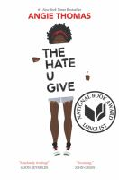

The Hate U Give
by Angie Thomas

The thought-provoking story of Starr Carter, a 16-year-old who sees her childhood best friend fatally shot by a police officer.

Also by this author:
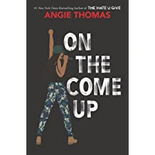
On the Come Up
by Angie Thomas

YA fiction- Melissa De La Cruz Historical fiction/Romance
#1 New York Times bestselling author Melissa de la Cruz brings to life the romance of young Alexander Hamilton and Elizabeth Schuyler

Alex and Eliza

Alex and Eliza (2017)
Love & War (2018)
All for One (2019)

Another series by this author:
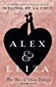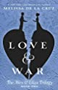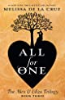
.

Blue Bloods
1. Blue Bloods (2006)
2. Masquerade (2007)
3. Revelations (2008)
4. The Van Alen Legacy (2009)
5. Misguided Angel (2010)
6. Lost In Time (2011)

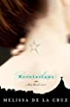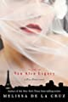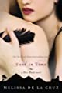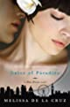

Nonfiction – Dog Training

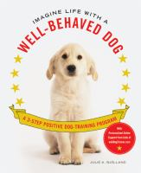
Imagine life with a well-behaved dog : a 3-step positive dog training program / Julie A. Bjelland
636.7 BJE

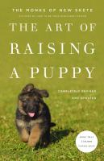

The art of raising a puppy / the Monks of New Skete

636.707 MON

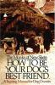

How to be your dog's best friend : a training manual for dog owners / the Monks of New Skete
636.7 MON

